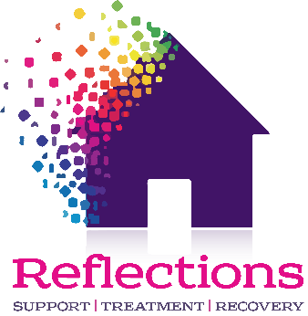 **Geoff & the joy of Recovery**

**A tumultuous start**

**Geoff was born and raised in Sheffield, the product of a dysfunctional and addiction fuelled household. He never felt safe as a child and would fantasise at night of being in outer-space or somewhere else safe, far away.**

School was no better and he found himself excluded at 13, unable to find another school that would accept him. Hanging around with the wrong crowd followed and an adolescent life selling drugs and feeling a naïve sense of invincibility.

*“I believe I was born an addict, been brought up to be co-dependent, learned to be dependent on some sort of substance, my traumas as a kid I used to have some bad night tremors, horrific, and that kid sat in the corner staring at the wall terrified, only way I could get to sleep at night was to imagine myself in outer space in a bubble or under the stairs, barricaded, my own little safe space with my quilt, could never settle.”*

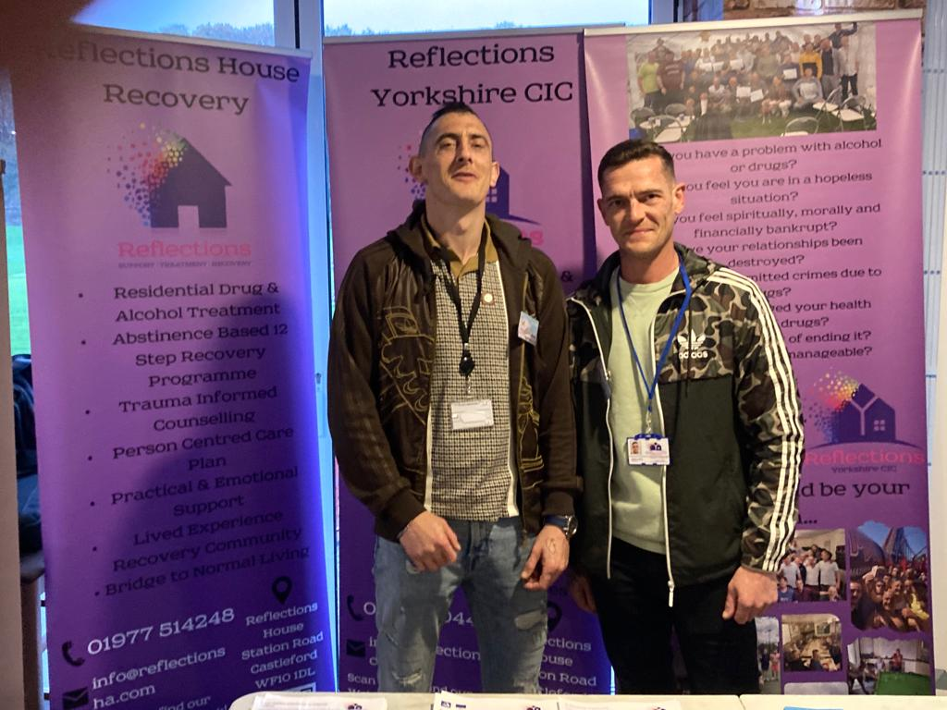**Humble endeavours fated to a black hole**

Geoff eventually became a proficient welder, earning decent money, but despite having a young family and a good income he could not evade his addictive tendencies, which for several decades would consume him.

Heroin & crack cocaine became his drug of choice (or compulsion) with the usual obligatory life of misery and disappointment devouring him.

He came to Reflections, broken spiritually and physically, whilst dependent on methadone. The growth he achieved quickly gave him the impetus to discard methadone within weeks of his arrival, albeit with some physical discomfort.

**Vulnerability and recovery reconstruction**

In recovery Geoff just grew and grew, working through the 12 steps he learned to understand himself, his mind, his emotions, his demons, and his triggers. Now over a year clean off of any mind-altering substances he now a sponsor of newcomers to recovery, a doting father, and a shining beacon of hope for anyone.

Despite a turbulent upbringing, addiction to drugs, and deep-rooted mental health issues he is evidence that if you put the work in you can triumph through adversity.

Geoff is now a volunteer at Reflections, looking forward to developing his career in using his workshop skills to help and empower others to show them that they can still engage in practical work that can lead to employment.

He is now giving back to a world from with he took so much living the path of recovery thanks to the abstinence-based trauma-informed 12-step programme at Reflections and the supportive community.

*“I have hope now, how can you deny hope… I have my bad days of course - but that’s ok. If I start dismissing my feelings then it gets a bit heavy, but I feel well - no longer poor me, the victim.”*